**Cosine mixture:**

<http://jakobbossek.github.io/smoof/reference/makeCosineMixtureFunction.html>

<https://al-roomi.org/benchmarks/unconstrained/n-dimensions/166-cosine-mixture-function>

MAXIMIZAÇÃO

n = ?

xi [-1,1]

f(X*) = 0,1 para n=1

f(X*) = 0,2 para n=2

...

**McCormick: OKKKKKKKKKKKKKKKKKKK**

<https://al-roomi.org/benchmarks/unconstrained/2-dimensions/61-mccormick-s-function>

<https://www.sfu.ca/~ssurjano/mccorm.html>

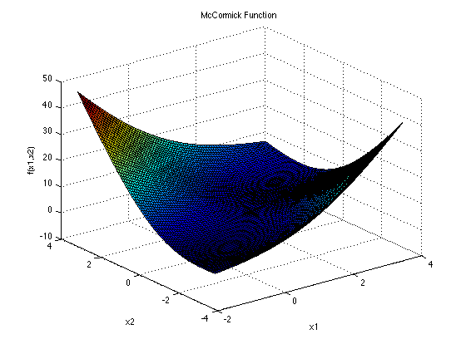

n = 2

x1 [-1.5, 4]

x2 [-3, 4]

f(X*) = −1.9133

x* = (−0.54719, −1.547197)

**Paviani: OKKKKKKKKKKKKKKK**

<http://infinity77.net/global_optimization/test_functions_nd_P.html>

<http://www.geocities.ws/eadorio/mvf.pdf>

This is a multimodal minimization problem

n = 10

xi [2,10]

f(X*) = -45.7784

x* = (9.340266, 9.340266, ...)

**Salomon: OKKKKKKKKKKKKKKK**

<https://www.indusmic.com/post/salomon-function>

<https://al-roomi.org/benchmarks/unconstrained/n-dimensions/184-salomon-s-functio>

The function is continuous, not convex, defined on n-dimensional space, multimodal, differentiable, non - separable.



n = 2 ou ?

xi [-100, 100]

f(X*) = 0

x* = (0, 0, ...)

**Alpine 01: OKKKKKKKKKKKK**

<http://infinity77.net/global_optimization/test_functions_nd_A.html>

<https://al-roomi.org/benchmarks/unconstrained/n-dimensions/162-alpine-function-no-1>

This is a multimodal minimization

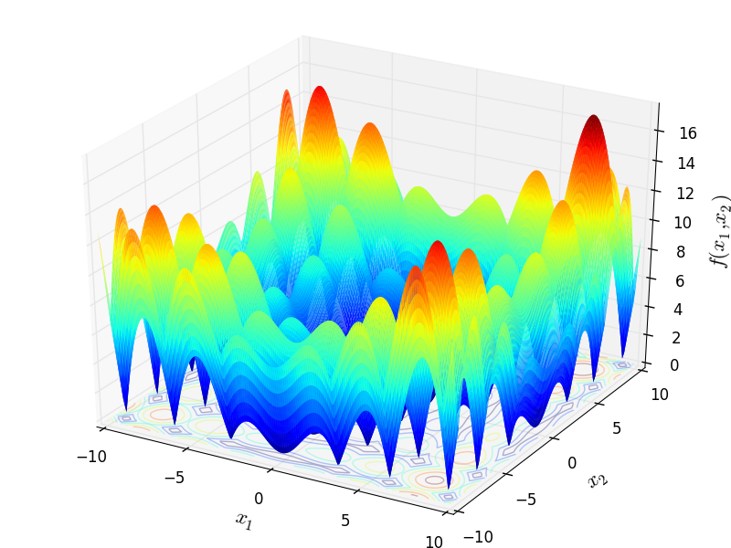

n = 2 ou ?

xi [-10, 10]

f(X*) = 0

x* = (0, 0, ...)

**Schaffer 02: OKKKKKKKKKKKKKKKKK**

<https://www.sfu.ca/~ssurjano/schaffer2.html>

<https://www.indusmic.com/post/python-implementation-of-schaffer-function>

The second Schaffer function. It is shown on a smaller input domain in the second plot to show detail.

This function is unimodal, continuous, not convex, differentiable, non-separable, defined on 2-dimensional space.

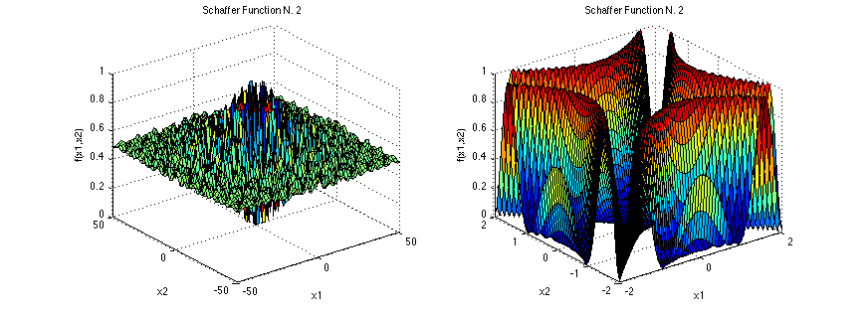

n = 2

xi [-100, 100]

f(X*) = 0

x* = (0, 0, ...)

**Bartels Conn: OKKKKKKKKKKKKKK**

<https://al-roomi.org/benchmarks/unconstrained/2-dimensions/72-bartels-conn-s-function>

<https://www.indusmic.com/post/bartels-conn-function>

The function is not convex, defined on 2-dimensional space, non-separable, non-differentiable.



n = 2

xi [-500, 500]

f(X*) = 1

x* = (0, 0, ...)

**Adjiman:**

<https://al-roomi.org/benchmarks/unconstrained/2-dimensions/113-adjiman-s-function>

<https://www.indusmic.com/post/happy-cat-function>

<http://infinity77.net/global_optimization/test_functions_nd_A.html>

The function is not convex, differentiable, non-separable, defined on 2-dimensional space.

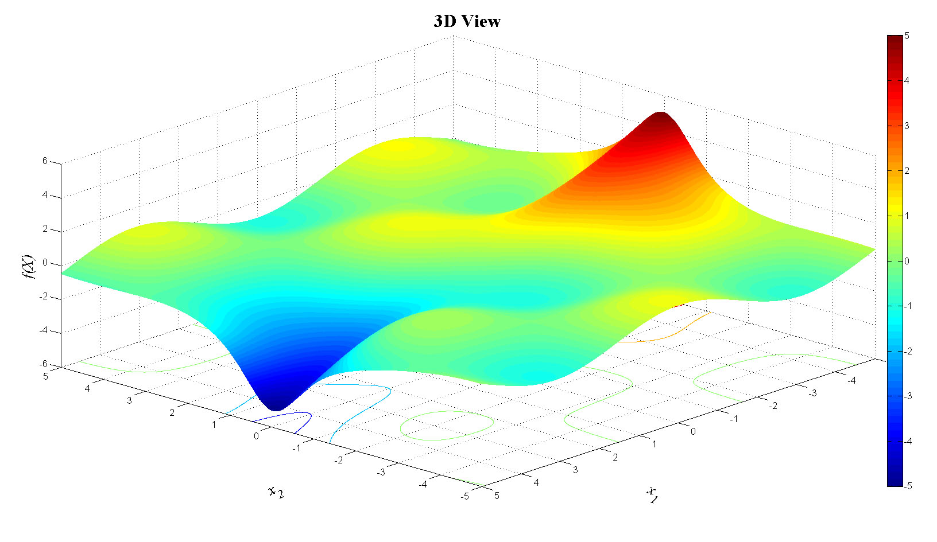

n = 2

x1 [-1, 2]

x2 [-1, 1]

f(X*) = 0

x* = (0, 0)